Job Title: Assistant Mining Consultant and Information Manager
Department: Information and AI
Reports to: Team Leader- Data Improvement
Direct Reports: None
Location: Activity-based onsite
Contract Type: Permanent
Grade: CA4

Main purpose of the job

The Information and AI department is embarking on a large programme of work to specifically improve and update the Mining Information Database. This programme will feature a number of projects looking at key information datasets and improving them to ensure this information is fit for the future. In order for this programme to succeed, the Information and AI department is looking for motivated professionals to undertake this important work.

- Undertake mining information improvement projects to ensure the business satisfies its statutory, legal and GDPR obligations.
- Perform investigation of mining data queries using mine abandonment plans, historical plans and records, and a Geographical Information System (GIS).
- Assist in reviewing and assessing new mining information and updating the corporate GIS database.
- Work on specific improvement projects to improve the Mining Information database.
- Provide administrative support for the Mining Consultant and Information Managers for the provision of information service to the business.
- Provide general support to the line manager and Mining Consultant and Information Managers as required

Responsibilities

Specific
- To work on improving the mining data held by the CA through targeted project work.
- To provide accurate, complete and timely information services to all the Authority’s operational departments, customers and stakeholders.
- To assist in providing expert technical advice and support for internal and external customers.
- To provide technical support to manage the coal mining records archive including new deposits and the cataloguing of new abandonment plans.
- To assist in ensuring information and data across all business areas is fit for operational use and re-using, for both internal and external customers.
- To use GIS, specifically ESRI ArcGIS, to interrogate, amend and visualise data.
- To ensure all information is adequately protected in regards to copyright, database rights, intellectual property rights as well as licence or other contractual relationships.
- To provide the information and technical support in any related developments of IT systems which underpin the management and provision of information for its re-use.
- To support the development of a commercial and non-commercial provision of information and services.
- To assist the line manager as required.

General

- Act in line with the behaviours and values of the organisation.
- Manage your own performance to be accountable for meeting individual, team and corporate objectives.
- Act in accordance with the Scheme of Delegation and ensure propriety and regularity in the handling of public funds.
- Actively demonstrate the Mining Remediation Authority’s customer service standards expected of your role.
- Follow and contribute to the improvement of operational and team processes and procedures.
- Assist with the preparation and delivery of the team’s objectives, budgets and financial records.
- Identify opportunities and implement change leading to team development, system improvement and ensuring good value for money.
- Maintain and develop positive stakeholder relationships in order to promote the Authority and assist it to meet its objectives.
- Support research and development projects.
- Ensure that the Authority’s statutory responsibilities are effectively discharged.
- Carry out any further reasonable requests from your line manager.

Competencies Level
Seeing the bigger picture - has an in-depth understanding and knowledge of how the role fits with and supports The Mining Remediation Authority’s business priorities | 3
Changing and improving - responsive, innovative and seek out opportunities for continuous improvement | 3
Making effective decisions - objective; uses sound judgement, evidence and knowledge to provide accurate, expert and professional advice in a timely manner | 3
Leading and communicating - leads from the front and communicates with clarity, conviction and enthusiasm | 3
Collaborating and partnering - creates and maintains positive, professional and trusting working relationships with a wide range of people, within and outside The Mining Remediation Authority, to achieve results | 3
Building capability for all - has a strong focus on continuous learning for self, others and the organisation | 3
Achieving commercial outcomes - has a commercial, financial and sustainable mind-set to ensure all products and services deliver added value and stimulate growth | 3
Delivering good value for money - achieves a good mix of quality and effectiveness for minimal cost and to improve return on investment | 3
Managing a quality service - plans, organises and manages their time and activities to deliver a high-quality customer experience | 3
Delivering at pace - delivers timely performance, with energy, and taking responsibility and accountability for high-quality outcomes | 3

Person specification
Job Title: Assistant Mining Consultant & Information Manager Department: Information and AI
 | Essential | Desirable
Qualifications and Training | - (No minimum qualification set if candidate can demonstrate relevant experience at desirable level) | - Degree (or equivalent) or demonstrable experience in geology, mining, minerals, geotechnical engineering, earth science, GIS or information management  - Information Management qualification or experience  - GIS qualification
Experience and Knowledge | - Experience of working with customers and the general public  - Experience of using information in a GIS application  - An understanding of mining particularly in relation to coal.  - Competency with use of Microsoft Office software. | - Experience interpreting mining related plans and records.  - Geographic Information and IT systems development and testing.  - Experience and interpreting site investigations and geological records.
Skills and Abilities  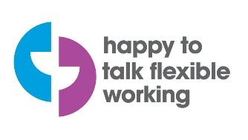  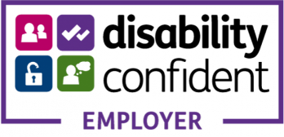  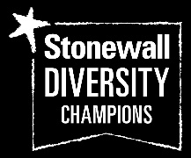   | - GIS/ CAD experience  - Reading maps and plans  - Research skills  - Good communication skills  - Ability to prioritise tasks and use initiative  - Effective time management | - Specification writing

