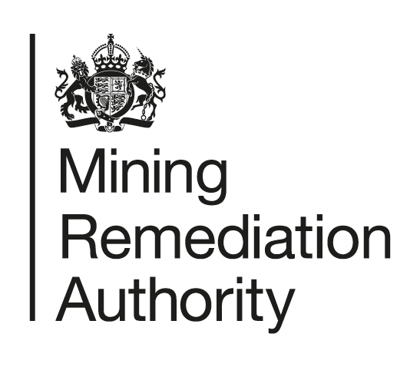

**Job Title**: Research & Development Delivery Manager

**Department:** Environment Delivery - Metal Mines

**Reports to:** Principal Programme Manager DEFRA

**Direct Reports:** None

**Main purpose of the job**

* To deliver the agreed annual programme of R&D activities to support research, development and innovation across the metal mine programmes in line with Defra, NRW and the Mining Remediation Authority’s Corporate Objectives.
* To manage internal and external resources, including contractors and equipment to support the successful delivery of R&D projects.
* Provide technical support and advice within the individual’s area of expertise.

**Responsibilities**

**Specific**

* Responsible for development of detailed plans for new R&D projects including scope, objectives, timescales and budget for agreement by the Principal Programme Manager (Metal Mines) and Programme Leads.
* Responsible for the in-year delivery of R&D activities across the Metal Mine programmes including budgeting, financial reporting, risk management and management of internal and external resources.
* To engage with managers in other technical areas to involve staff with relevant skills and knowledge in R&D activities to maximise the benefits to the Mining Remediation Authority and our delivery partners.
* To manage intellectual property issues arising from individual projects.
* To develop a network of key stakeholders (external and internal) to support delivery of R&D and add value.
* To identify potential opportunities for external funding for R&D activities and support the Principal Programme Manager to realise these.
* To support the Principal Programme Manager in horizon scanning and identifying new opportunities and risks that can be addressed through R&D.
* To support the Principal Programme Manager in the preparation of reports and papers on R&D for the Programme Boards or other governance groups as required.
* Manage R&D projects or contribute to them by providing specialist scientific or analytical skills in your area of expertise.
* Be responsible and accountable for any project budget under the role’s control.
* Ensure scientific rigour is employed in the design and running of R&D projects or where you are providing specialist support.
* Help identify and realise benefits from R&D projects and disseminate any learning both within the Authority, across programmes and externally.
* Help promote the Authority and improve its public profile, as required, and to personally publish or present papers as required by the Principal Programme Manager or our delivery partners.
* Attend field visits and site meetings as required.
* Attend meetings and conferences in the UK and overseas, where required, to further the Authority’s R&D projects or collaborative relationships.

**General**

* To act in accordance with the behaviours and values of the organisation.
* To manage your own performance to be accountable for meeting individual, team and corporate objectives.
* To act in accordance with the Scheme of Delegation and ensure propriety and regularity in the handling of public funds.
* To actively demonstrate the Mining Remediation Authority’s customer service standards expected of your role.
* To comply with and contribute to the improvement of operational and team processes and procedures.
* To assist with the preparation and execution of the team’s objectives, budgets and financial records.
* To identify opportunities and implement change leading to team development, system improvement and good value for money.
* To maintain and develop positive stakeholder relationships in order to promote the Authority and assist it to meet its objectives.
* To support research and development projects.
* To ensure that the Authority’s statutory responsibilities are effectively discharged.
* To carry out any further reasonable requests from your line manager.

**Competencies Level**

|  |  |
| --- | --- |
|  |  |
| **Seeing the bigger picture** - has an in-depth understanding and knowledge of how the role fits with and supports The Mining Remediation Authority’s business priorities | **4** |
| **Changing and improving** - responsive, innovative and seek out opportunities for continuous improvement | **4** |
| **Making effective decisions** - objective; uses sound judgement, evidence and knowledge to provide accurate, expert and professional advice in a timely manner | **4** |
| **Leading and communicating** - leads from the front and communicates with clarity, conviction and enthusiasm | **5** |
| **Collaborating and partnering** - creates and maintains positive, professional and trusting working relationships with a wide range of people, within and outside The Mining Remediation Authority, to achieve results | **4** |
| **Building capability for all** - has a strong focus on continuous learning for self, others and the organisation | **4** |
| **Achieving commercial outcomes** - has a commercial, financial and sustainable mind-set to ensure all products and services deliver added value and stimulate growth | **4** |
| **Delivering good value for money** - achieves a good mix of quality and effectiveness for minimal cost and to improve return on investment | **4** |
| **Managing a quality service** - plans, organises and manages their time and activities to deliver a high-quality customer experience | **4** |
| **Delivering at pace** - delivers timely performance, with energy, and taking responsibility and accountability for high-quality outcomes | **4** |

**Person specification**

|  |  |  |
| --- | --- | --- |
| **Job Title:** Research & Development Delivery Manager **Department:** Environment Delivery - Metal Mines | | |
|  | **Essential** | **Desirable** |
| **Qualifications and Training** | A suitable degree (or equivalent qualification) in a relevant scientific or engineering (such as geoscience, chemistry, environmental science/engineering) discipline or demonstrable experience in R&D project management in an academic or industrial setting. | Masters by research or PhD in a relevant scientific or engineering discipline ideally directly related to the Authority’s areas of activity.  Recognised qualifications or training in project management.  Chartered status from your relevant learned body or professional society. |
| **Experience and Knowledge** | Project Management experience, including budgetary management and forecasting.  Experience of academic or industrial research.  A broad scientific understanding with an ability to address a wide range of issues. | Knowledge in the Authority’s areas of operations  Experience of undertaking R&D directly related to the Authority’s areas of operations particularly in mine water treatment.  Experience of working on operational/construction sites.  Familiarity with IP rights issues and R&D contracting |
| **Skills and Abilities** | Ability to manage a diverse and challenging portfolio of projects and other activities.  Organisational skills and an eye for detail.  Effective approach to risk management.  Excellent communication and interpersonal skills (inc. Report writing).  Ability to assimilate information, analyse data and challenge thinking.  Decision making skills. | Public Speaking Skills  Ability to lead change. |
| **Other** | Field visits are regularly carried out and there is a requirement to wear protective clothing. Other off site meetings and visits will also be required. Average of three visits every month. Occasional overnight stays will be required. Travel on a national, or occasionally international, basis. Approximately 5,000 miles per year |  |

     