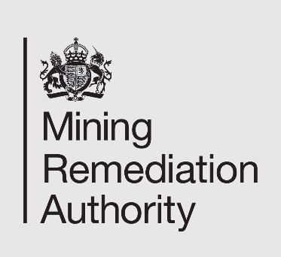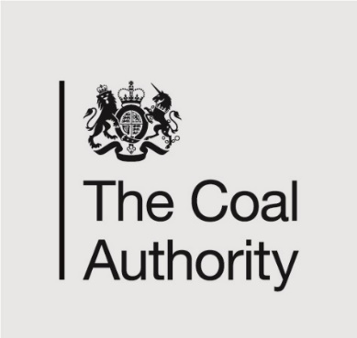

**Job Title**: Geochemist

**Department:** Environment Strategy & Sustainability

**Reports to:** Technical Lead - Chemistry

**Direct Reports:** None

**Grade:** CA5

**Main purpose of the job**

* To act as a scientific specialist on coal and metal mine water geochemistry for the Mining Remediation Authority, providing technical guidance on all aspects of this area to operational and project teams as well as senior management.
* To develop and review treatment concepts, define sampling programmes, review and analyse chemical data and evaluate technical risks associated with the design, development, construction, operation and maintenance of mine water treatment systems for coal and metal mine waters.
* To promote the Mining Remediation Authority as an expert body in mine water management, representing the organisation in external meetings and conferences.

**Responsibilities**

**Specific**

* Ensure the chemical data for operational schemes and assigned project activities is managed with appropriate data input, quality control and reporting. Close liaison with Laboratory to ensure smooth service provision and work with Operational Contract Managers
* Regularly reviewing the coal and metal mine sampling programmes to ensure they are correct and that the sampling programme agrees with business requirements
* Provide advice to development projects (coal and metal mine) including reviewing proposals for treatment options and sizings.
* Metal mine water assessment, interpretation, and advice on treatment options. Assist with chemical process engineering treatment issues.
* Provide advice re samples taken as part of enquiries investigating the origin of waters. Liaison and advice to those taking samples on behalf of the Authority, internal engineers and external contractors.
* Field monitoring to investigate specific chemical characteristics / processes / performance; managing contractors to do this as required
* Identify changes (trends) in chemistry at monitored and operational sites, and investigate and recommend with other internal experts on treatment options. Ensure operational team are alerted by exception to failures (actual or likely) of consent parameters at treatment schemes and reporting on efficiency.
* Respond to requests for data from external stakeholders in line with Mining Remediation Authority procedures.
* Reviewing publications related to mine water chemistry, geochemistry and treatment, and feed back to the team.
* Work with hydrogeologists in various tasks including specifying sampling from shafts, and estimating/ predicting chemistry of rising mine water.
* To liaise with regulators to achieve best environmental permit conditions for mine water and commenting on consultations regarding external regulation or legislative changes which could impact on the Mining Remediation Authority.
* To produce technical reports and briefings as required.

**General**

* Act in line with the behaviours and values of the organisation
* Manage your own performance to be accountable for meeting individual, team and corporate objectives
* Act in accordance with the Scheme of Delegation and ensure propriety and regularity in the handling of public funds
* Actively demonstrate the Mining Remediation Authority’s customer service standards expected of your role
* Follow and contribute to the improvement of operational and team processes and procedures
* Assist with the preparation and delivery of the team’s objectives, budgets and financial records
* Identify opportunities and implement change leading to team development, system improvement and ensuring good value for money
* Maintain and develop positive stakeholder relationships in order to promote the Authority and assist it to meet its objectives
* Support research and development projects
* Ensure that the Authority’s statutory responsibilities are effectively discharged
* Carry out any further reasonable requests from your line manager

**Competencies Level**

|  |  |
| --- | --- |
|  |  |
| **Seeing the bigger picture** - has an in-depth understanding and knowledge of how the role fits with and supports The Mining Remediation Authority’s business priorities | **4** |
| **Changing and improving** - responsive, innovative and seek out opportunities for continuous improvement | **4** |
| **Making effective decisions** - objective; uses sound judgement, evidence and knowledge to provide accurate, expert and professional advice in a timely manner | **4** |
| **Leading and communicating** - leads from the front and communicates with clarity, conviction and enthusiasm | **4** |
| **Collaborating and partnering** - creates and maintains positive, professional and trusting working relationships with a wide range of people, within and outside The Mining Remediation Authority, to achieve results | **4** |
| **Building capability for all** - has a strong focus on continuous learning for self, others and the organisation | **4** |
| **Achieving commercial outcomes** - has a commercial, financial and sustainable mind-set to ensure all products and services deliver added value and stimulate growth | **4** |
| **Delivering good value for money** - achieves a good mix of quality and effectiveness for minimal cost and to improve return on investment | **4** |
| **Managing a quality service** - plans, organises and manages their time and activities to deliver a high-quality customer experience | **4** |
| **Delivering at pace** - delivers timely performance, with energy, and taking responsibility and accountability for high-quality outcomes | **4** |

**Person specification**

|  |  |  |
| --- | --- | --- |
| **Job Title:** Geochemist  **Department:** Environment Strategy & Sustainability | | |
|  | **Essential** | **Desirable** |
| **Qualifications and Training** | Degree in Chemistry (Environmental Chemistry, Geochemistry, Hydrochemistry), Geology (Earth Science, Environmental Earth Science) or be able to demonstrate suitable relevant experience in the area of expertise.  Working towards chartered status with an appropriate professional body. | Higher level relevant degree (MSc or PhD)  Chartered status with relevant professional body |
| **Experience and Knowledge** | Experience of mining/environmental projects (for coal and metal mines) and knowledge of applied mine water chemistry and geochemistry.  Experience of design of and conducting of environmental field monitoring and sampling programmes | Experience of geochemical modelling  Knowledge of biological/microbial treatment processes  Knowledge of contaminated sediments |
| **Skills and Abilities** | Ability to work under pressure  Excellent communication and interpersonal skills  Excellent IT skills  Excellent report writing skills  Contract management  Scientific analysis (laboratory and field)  Scientific presentations | Research project management  Geochemical modelling |
| **Other** | Full UK Driving Licence, or equivalent, allowing business travel to all UK areas  Frequent travel on business to attend meetings or visit monitoring sites  Approx. 7-10,000 miles per year  Occasional nights away from home, up to two times per month  Possible future overseas working required |  |

 